**Nakshatra Based Weather Forecast During Punarvasu and Pushyami Karte**

**( Shubhakruthu Nama Samvatsara, July Month forecast from 06-07-2022 to 02-08-2022)**

**By Dr.Aravind Swamy PhD**

**Punarvasu Karte:** Punarvasu Karte starts from 06-07-2022 to 19-07-2022. ( Kandavrushti- Continuous rain) When Sun enters Punarvasu nakshatra in Gemini sign ( Airy Sign) at 11:11 AM at that time Lagna is Virgo and moon is posited in Uttaraphalguni nakshatra.

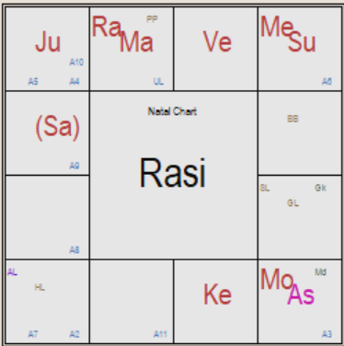Planetary position during Punarvasu karte, Sun and mercury are in Gemini sign and the moon is posited in Virgo sign in Uttaraphalguni nakshatra. Saturn is aspecting Mars and Rahu. Jupiter is aspecting lagna. Climatic conditions will be cold and widespread throughout India. Climate will be cloudy and windy with thunders, heavy rains to moderate rains are expected in many regions of India. rains will be heavy in the central India and coastal areas, Northeaster regions, and western regions of India.

Sun and Mercury will transit into Cancer sign on 17-07-2022 sudden changes in the atmosphere will occur and cyclone / Depression will be formed in the North -East direction of the Bay of Bengal during this period gives above normal rainfall. Clouds will cover major portion of India resulting in above normal or heavy rains causing flood like situations in central and western parts of the country.

When moon transits to Hasta nakshatra rainfall will be in the range of above 75 mm, Chitra and swathi nakshatras will give below 25 mm rainfall and moon transit in Vishaka nakshatra will give above 120 mm rainfall in Hyderabad.

Gold, Silver, cotton, millets and cotton prices will be lower and fluctuating during this period. there will be an increase in the prices of other commodities. Southern countries and Northern and eastern regions will suffer from hardships/ Troubles and war like situations during this period.

**Pushyami Karte:** Pushyami karte starts from 20-07-2022 to 02-08-2022. (Alpavrushti)

When Sun enters Pushyami nakshatra in cancer sign ( Watery Sign) at 10:49 AM at that time Lagna is Virgo and moon is posited in Uttaraphalguni nakshatra the lagna. Saturn is aspecting the Jupiter, Fiery Mars is aspecting Mercury and Sun in watery, cancer sign. Jupiter and Saturn is aspecting the Mercury and Sun posited in cancer sign.

Climatic conditions during the Pushyami karte are widespread clouds, cold climate with winds. Planetary positions and aspects of Saturn and Mars during Pushyami karte indicates earthquakes, accidents in the sky and water. Depression or Cyclone will be formed during this karte and will have long term effect on the climate. Depression will be formed in Bay of Bengal during this period. North-Eastern regions of the country will receive very good rainfall.

When moon transits to Revathi nakshatra rainfall will be in the range of above 40 mm, Ashwini and Bharani nakshatras will give above 25 mm rainfall and when moon transits in Kritika nakshatra will give above 140 mm rainfall in Hyderabad.

Gold, Silver, dry fruits and metals are highly fluctuating and move towards higher prices during this period. there will be an increase in the prices of other commodities. This will be tough period for the rulers and tough period in northern regions. Southern and western regions will have flood like situations.

*With Guru ji blessings these observations and calculations are made according to the astrology texts and literature. Any deviation in the predicted results is due to erroneous analysis but not due to the Astrology literature. I am trying my best to understand the subject and try to create awareness by predicting the rainfall based on nakshatras. I hope you will encourage me to improve the deeper understanding of Astro Science beyond limitations. I hope you will accept this article and forgive my mistakes.*

*M.L. Arvinda Swamy ( Ph.D 2019-2021)*